
14 Oct 2019

ITRW 321 Assignment 2 Extraction, Transformation and Loading into DSS
Group 1 – The Nerd Herd
Alwyn Barnard (Group leader) 28430093
Anerique van der Walt 28467078
Welmari Odendaal 28975383
Sarina Haasbroek 27035824

Table of Contents
1. Description of Group 2
1.1. Company objectives 2
1.2. Company operations 2
2. Define problems and constrains 2
. Define objectives to solve problems identified 3
3.3. Scope 3
2. Data store components (DSS Tables) 4
ER Diagram 4
Three Star Schemes 5
Required information scenario 1: Display total sales transaction per year per month per artist. 5
Required information scenario 2: Display the top 5 artist per year per month. 7
Required information scenario 3: Display average sales per medium 7
Required information scenario 4: Display the total inventory per year per month per collection. 9
SQL for Creating DSS Tables and Constraints 12
2. Initial Data Extraction from Operational Tables or External Sources (Extract & Transform) 14
SQL to populate table TOTAL_SALES 14
3. Data Loading 17
SQL for Creating of Indexes 17
SQL for Transactions 17
4. Regular Update/Refresh of Data from Operational Database or External Sources 19
SQL to populate table TOTAL_SALES 19
5. SQL Queries to Provide Information for Decision Making 22
6. Optimized SQL Statements 25
7. Database Created in Oracle 26
8. Extra Functionality 31
Charts and Reporting 31
List of Artwork Currently in Museum per Collection 31
Medium Types Used by Tel Aviv Museum of Arts 31
Relation of Artist to Artwork and Their Collections 32
Tel Aviv Museum of Art Data Types 32

1. Description of Group
The Tel Aviv Museum didn’t really have any information system in place
The new information system is designed for a small gallery. The system will improve the performance and communication by using an integrated and uniform system that will support the information system.

Company objectives
- Simplify the entering of new data into the database for the end users.
- Provide security, integrity, confidentiality, and privacy of the database.
- Improve communication and collaboration between the end user and the database.
- Improve the processing time and improve the overall performance.
- Update the efficiency of the change function of the database.
- Facilitate the day-to-day operations by effectively retrieving data and storing when instructed. The previous system regularly failed and produced inaccurate results.
- Implement a system that will help the company reach their current and future objectives and needs.

Company operations
The Tel Aviv Museum of Art (TAMoA) is an art gallery that primarily imports different mediums of art and displays them for periods of time. Most often these artworks are on sale and these sales are processed through the sales and financial departments. At TAMoA the clients can request bought artwork to be shipped or held on site. Artworks can be held on show or be sold. Members can join a mailing list that updates them on events at the gallery.
- A client can request to be added to the mailing list of the museum and be informed of upcoming events. The client can also request to buy artwork from the museum.
- Artists can buy or sell artwork, but they can also request to only exhibit artwork on site.
- After the purchase request the sales department will create a purchase report and send it off to the logistical and financial departments. The logistical department will then plan for delivery.

Define problems and constrains

The company day to day operations is not executed efficiently because of a poorly design database.
The following problems was identified:
- The database does not provide full information about an art piece e.g. The system only provides the name of the artist and estimated value.
- The gallery does not use a uniformed database e.g. The gallery makes use of different application such as excel and access to maintain and store data.
- The database did not show any commission or statements obtained when selling the art work.
- The database does not support maintenance of database e.g. cannot update information of the art due to data redundancy.
- Not all data have been digitised. Records are currently in the organization’s journals.
- There is no provision made for backup management.

The following constraints needs to be implemented:
- All the data entered needs to be in the correct format.
- All attributes need to be in a specific range.
- Each table needs to have a primary key to ensure entity integrity.
- No attributes can have a null value.
- Security, confidentiality, and privacy of the database.

. Define objectives to solve problems identified
- Provide a new database that can contain relevant data about the art piece.
- Provide a uniformed database: existing data in other databases needs to be restructured to ensure compatibility with the database.
- Execute the necessary and correct calculations: The commission of the artwork will be calculated when it is sold.
- Correctly process and record a transaction: appropriate adjustments will be made to the database to record the transaction.
- Provide functionality that will support maintenance: Select an appropriate Database management system (DBMS) that will facilitate the maintenance of the database:
- To have a complete database: all data will be converted and loaded into the new database.
- Provide functionality that will support backup: Select an appropriate DBMS that will support full backup, differential backup and transaction log backup.
- Some information that will be stored in the database is:
  - Keep track of sales, amounts, profits and relevant sold items.
  - Keep track of day-to-day operations and activities.
  - Keep track of monthly reports.
  - Summarise large amounts of data relating to a department or specific time frame e.g. Monthly, yearly, etc.

3.3. Scope
A database needs to be constructed that provides a full description of the artwork and support all the requirements of the end-user. The database should only contain relevant information. Data should be processed and delivered at the appropriate time to ensure good decision making.

The previous database system does not satisfy the system user requirements anymore; therefore, a new improved system needs to be implemented. In order to address the system user’s needs the newly implemented database needs to facilitate better productivity and improved system performance.
- The database should encompass all data from the entire museum and not just individual departments. The information must be integrated in the new system.

2. Data store components (DSS Tables)

ER Diagram
 | COLLECTION
PK | Collection_ID
FK | Artist_ID
 | Collection_Name

 | CITY
PK | City_Code
 | City_Name
 | City_Postal_code

 | CLIENTS
PK | Client_ID
FK | City_Code
 | Client_Initial
 | Client_LName
 | Client_RSA_ID
 | Client_Cell
 | Client_Email
 | Client_Street_Adress
 | Street_Nr

 | SALES_TRANSACTION
PK | Transaction_ID
FK | Client_ID
 | Sales_Date
 | Comission
 | VAT
 | Delivery_Method
 | Sales_Total

 | SALES_TRANSACTION_DETAIL
(PK)(FK) | Transaction_ID
(PK)(FK) | Artwork_ID
 | Sales_Price

 | ARTWORK
PK | Artwork_ID
FK | Collection_ID
FK | Medium_Code
 | Artwork_Title
 | Artwork_DOC
 | Length_cm
 | Length_cm
 | Artwork_Status
 | Artwork_Established_Value

 | MEDIUM
PK | Medium_Code
 | Medium_Description

 | ARTIST
PK | Artist_ID
FK | Bank_Code
 | Artist_Initial
 | Artist_LName
 | Artist_RSA_ID
 | Artist_Cell
 | Artist_Email
 | Artist_Account_No
 | Artist_DOB
 | Artist_DOD

 | BANK
PK | Bank_Code
 | Bank_Name

1..1
has
1..*

lives in
1..*
is created
1..1
has
1..*
belongs to
1..1
includes
1..* made from
1..1 used by
1..1 contains
1..* belongs to
1..*
have
1..1
is part of

1..* was created by
1..1 creates
1..*
uses
1..1
has

Three Star Schemes
Scenario 1:

Required information scenario 1: Display total sales transaction per year per month per artist.
DIMENSION | DESCRIPTION | POSSIBLE ATTRIBUTES
Time  - Year  - Month  Artist | - Year and month don’t require additional dimension table  - Artist required addition dimension table, because more info is required from artist than just the Artist_ID | Shown in table below

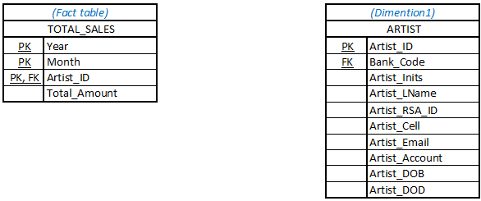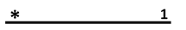
SQL to Create table TOTAL_SALES_FACT
DROP TABLE artist_dim CASCADE CONSTRAINTS;
DROP TABLE total_sales_fact CASCADE CONSTRAINTS;

CREATE TABLE artist_dim (
artist_id NUMBER(8) NOT NULL,
artist_lname VARCHAR(35),
artist_Inits VARCHAR(5),
artist_cell VARCHAR(11),
CONSTRAINT PK_STAR_artist_id PRIMARY KEY(artist_id)
);

--FACT TABLE
CREATE TABLE total_sales_fact
(
Year NUMBER(4) NOT NULL,
Month NUMBER(2) NOT NULL,
Artist_id NUMBER(10) NOT NULL,
Total_Amount NUMBER(10, 2) NOT NULL,
CONSTRAINT PK_STAR_total_sales_fact PRIMARY KEY(Year, Month, artist_id),
CONSTRAINT FK_STAR_total_artist_id FOREIGN KEY (artist_id) REFERENCES artist_dim(artist_id)
);

SQL to populate table TOTAL_SALES_FACT
ALTER TABLE
total_sales_fact DISABLE CONSTRAINT PK_STAR_total_sales_fact;
ALTER TABLE
total_sales_fact DISABLE CONSTRAINT FK_STAR_total_artist_id;

--POPULATE TOTAL SALES FACT TABLE
INSERT INTO total_sales_fact
SELECT DISTINCT EXTRACT(YEAR FROM st.sale_date) "Year",
EXTRACT(MONTH FROM st.sale_date) "Month",
a.artist_id,SUM(st.sales_total) "Total_Amount"
FROM
artist a, sale_transaction st, sale_transaction_detail std,
artwork art,collection c
WHERE
a.artist_id = c.artist_id
AND c.collection_id = art.collection_id
AND art.artwork_id = std.artwork_id
AND std.transaction_id = st.transaction_id
GROUP BY
EXTRACT(YEAR FROM st.sale_date),EXTRACT(MONTH FROM st.sale_date),a.artist_id;

INSERT INTO artist_dim
SELECT DISTINCT tsf.artist_id, a.artist_lname, a.artist_inits, a.artist_cell
FROM total_sales_fact tsf, artist a
WHERE tsf.artist_id = a.Artist_id;

Output: Total_Sales_Fact
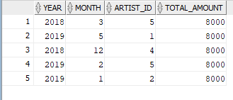
Artist_DIM
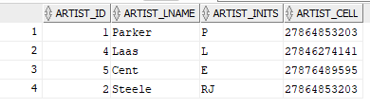

Scenario 2:

Required information scenario 2: Display the top 5 artist per year per month.
DIMENSION | DESCRIPTION | POSSIBLE ATTRIBUTES
Time  - Year  - Month  Artist | - Year and month don’t require additional dimension table  - Artist required addition dimension table, because more info is required from artist than just the Artist_ID | Shown in table below

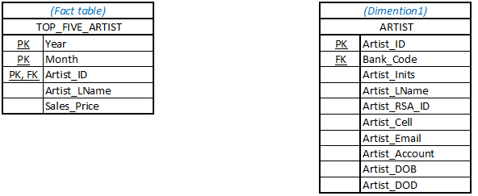
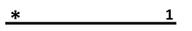
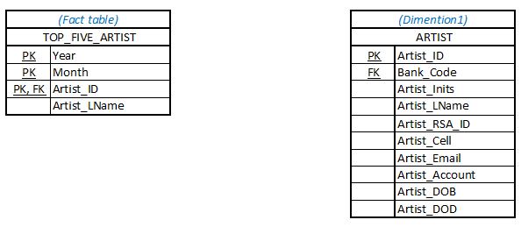

SQL to populate table TOP_FIVE_ARTIST
INSERT INTO top_five_artist
(SELECT TOP 5, EXTRACT(YEAR FROM st.sales_date) AS “Year”, EXTRACT (MONTH FROM st.sales_date) AS “Month”, a.artist_id, a.artist_lname, std.sales_price)
FROM sales_transaction st
JOIN sales_transaction_detail std
USING (transaction_id)
JOIN artwork a
USING (artwork_id)
JOIN collection c
USING (collection_id)
JOIN artist a
USING (artsist_id)
GROUP BY EXTRACT(YEAR FROM st.sales_date), EXTRACT (MONTH FROM st.sales_date) ;

:

Scenario 3:

Required information scenario 3: Display average sales per medium
DIMENSION | DESCRIPTION | POSSIBLE ATTRIBUTES
Medium | - This will display the average sales price of the artwork per medium | Shown in table below

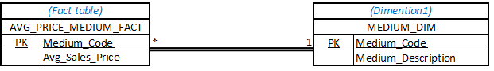

SQL to Create fact and dimention table AVERAGE_SALES
DIMENTION TABEL
CREATE TABLE medium_dim
(
medium_code NUMBER(5) NOT NULL,
medium_description VARCHAR(40),
CONSTRAINT PK_STAR_medium_code PRIMARY KEY(medium_code)
);

FACT TABLE
CREATE TABLE avg_price_medium_fact
(
Medium_code NUMBER(5) NOT NULL,
Average_Sales_Price NUMBER(10,2) NOT NULL,
CONSTRAINT PK _medium_code PRIMARY KEY(Medium_code),
CONSTRAINT FK_STAR_medium_code FOREIGN KEY (Medium_code) REFERENCES medium_dim(Medium_code)
);
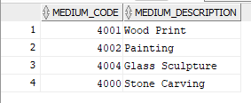
SQL to populate table AVERAGE_SALES
ALTER TABLE
avg_price_medium_fact DISABLE CONSTRAINT PK_medium_code;
ALTER TABLE
avg_price_medium_fact DISABLE CONSTRAINT FK_STAR_medium_code;

INSERT INTO avg_price_medium_fact
SELECT m.medium_code, AVG(sales_price) AS Average_Sales_Price
FROM sale_transaction_detail std,
artwork art,art_ medium m
WHERE m.medium_code = art. medium_code
AND art.artwork_id = std.artwork_id
GROUP BY m.medium_code;

DIMENTION TABLE
INSERT INTO medium_dim
SELECT DISTINCT apmf.medium_code, m.medium_description
FROM avg_price_medium_fact apmf, medium m
WHERE apmf.medium_code = m.medium_code;

SQL to regulate update to AVERAGE_SALES
FACT TABEL

INSERT INTO avg_price_medium_fact
SELECT m.medium_code, AVG(sales_price) AS Average_Sales_Price
FROM
sales_transaction_st ,sales_transaction_detail std,
artwork art, medium m
WHERE
m.medium_code = art. medium_code
AND art.artwork_id = std.artwork_id
AND std.transaction_id = st. transaction_id
AND st.sales_date > SYSDATE -1
GROUP BY m.medium_code;

SQL to provide info to users
SELECT t.medium_code , Average_Sales_Price
FROM avg_price_medium_fact t, medium_dim s
WHERE t. medium_code = s. medium_code;
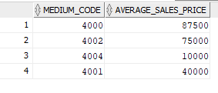

Scenario 4:

Required information scenario 4: Display the total inventory per year per month per collection.
DIMENSION | DESCRIPTION | POSSIBLE ATTRIBUTES
Time  - Year  - Month  Collection | - Year and month don’t require additional dimension table  - Collection required addition dimension table, because more info is required from artist than just the Collection_ID | Shown in table below
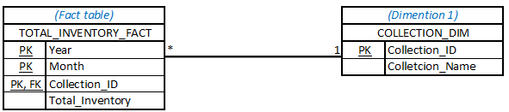

SQL to Create fact and dimention table TOTAL_INVENTORY
DIMENTION TABEL
CREATE TABLE collection_dim
(
Collection_id NUMBER(10) NOT NULL,
Collection_name VARCHAR(30),
CONSTRAINT PK_STAR_total_inventory PRIMARY KEY(collection_id)
);

FACT TABLE
CREATE TABLE total_inventory_fact
(
Year NUMBER(4) NOT NULL,
Month NUMBER(2) NOT NULL,
Collection_id NUMBER(10) NOT NULL,
Total_Inventory NUMBER(10) NOT NULL,
CONSTRAINT PK_STAR_total_inventory PRIMARY KEY(Year, Month, collection_id),
CONSTRAINT FK_STAR_collection_id FOREIGN KEY (Collection _id) REFERENCES collection_dim (Collection _id)
);

SQL to populate table TOTAL_INVENTORY
ALTER TABLE
total_inventory_fact DISABLE CONSTRAINT PK_total_inventory;
ALTER TABLE
total_inventory_fact DISABLE CONSTRAINT FK_STAR_collection_id;

FACT TABEL
INSERT INTO total_inventory_fact
SELECT DISTINCT EXTRACT(YEAR FROM st.sale_date) "Year",
EXTRACT(MONTH FROM st.sale_date) "Month",
c.collection_id,COUNT(art.artwork_id) "Total_ Inventory"
FROM sale_transaction st, sale_transaction_detail std,
artwork art,collection c
WHERE
c.collection_id = art.collection_id
AND art.artwork_id = std.artwork_id
AND std.transaction_id = st.transaction_id
GROUP BY
EXTRACT(YEAR FROM st.sale_date),EXTRACT(MONTH FROM st.sale_date),c.collection_id;
DIMENTION TABLE
INSERT INTO collection_dim
SELECT DISTINCT tif. collection_id, c.Collection_name
FROM total_inventory_fact tif, collection c
WHERE tif. collection_id = c. collection_id;

SQL to regulate update to TOTAL_INVENTORY
FACT TABEL
INSERT INTO total_inventory_fact
SELECT DISTINCT EXTRACT(YEAR FROM st.sales_date) "Year",
EXTRACT(MONTH FROM st.sales_date) "Month",
c.collection_id,COUNT(art.artwork_id) "Total_ Inventory "
FROM
sales_stransaction st, sales_transaction_detail std,
artwork art,collection c
WHERE
EXTRACT(YEAR FROM st.sales_date) = EXTRACT(YEAR FROM SYSDATE)
AND EXTRACT(MONTH FROM st.sales_date) = EXTRACT(MONTH FROM SYSDATE)
GROUP BY EXTRACT(YEAR FROM st.sales_date),
EXTRACT(MONTH FROM st.sales_date), c.collection_id;

SQL to provide info to users
SELECT t.year, t.month, t.collection_id, t.total_inventory
FROM total_inventory_fact t, collection_dim s
WHERE t.collection_id = s.collection_id;

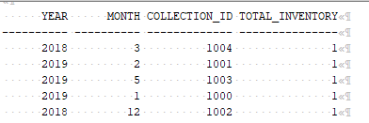

SQL for Creating DSS Tables and Constraints
SQL to Create fact and dimention table TOTAL_INVENTORY
DIMENTION TABEL
CREATE TABLE collection_dim
(
Collection_id NUMBER(10) NOT NULL,
Collection_name VARCHAR(30),
CONSTRAINT PK_STAR_total_inventory PRIMARY KEY(collection_id)
);

FACT TABLE
CREATE TABLE total_inventory_fact
(
Year NUMBER(4) NOT NULL,
Month NUMBER(2) NOT NULL,
Collection_id NUMBER(10) NOT NULL,
Total_Inventory NUMBER(10) NOT NULL,
CONSTRAINT PK_STAR_total_inventory PRIMARY KEY(Year, Month, collection_id),
CONSTRAINT FK_STAR_collection_id FOREIGN KEY (Collection _id) REFERENCES collection_dim (Collection _id)
);

CREATE TABLE artist_dim (
artist_id NUMBER(8) NOT NULL,
artist_lname VARCHAR(35),
artist_Inits VARCHAR(5),
artist_cell VARCHAR(11),
CONSTRAINT PK_STAR_artist_id PRIMARY KEY(artist_id)
);

SQL to Create table TOTAL_SALES_FACT

CREATE TABLE artist_dim (
artist_id NUMBER(8) NOT NULL,
artist_lname VARCHAR(35),
artist_Inits VARCHAR(5),
artist_cell VARCHAR(11),
CONSTRAINT PK_STAR_artist_id PRIMARY KEY(artist_id)
);

--FACT TABLE
CREATE TABLE total_sales_fact
(
Year NUMBER(4) NOT NULL,
Month NUMBER(2) NOT NULL,
Artist_id NUMBER(10) NOT NULL,
Total_Amount NUMBER(10, 2) NOT NULL,
CONSTRAINT PK_STAR_total_sales_fact PRIMARY KEY(Year, Month, artist_id),
CONSTRAINT FK_STAR_total_artist_id FOREIGN KEY (artist_id) REFERENCES artist_dim(artist_id)
);
SQL to Create fact and dimention table AVERAGE_SALES
DIMENTION TABEL
CREATE TABLE medium_dim
(
medium_code NUMBER(5) NOT NULL,
medium_description VARCHAR(40),
CONSTRAINT PK_STAR_medium_code PRIMARY KEY(medium_code)
);

FACT TABLE
CREATE TABLE avg_price_medium_fact
(
Medium_code NUMBER(5) NOT NULL,
Average_Sales_Price NUMBER(10,2) NOT NULL,
CONSTRAINT PK _medium_code PRIMARY KEY(Medium_code),
CONSTRAINT FK_STAR_medium_code FOREIGN KEY (Medium_code) REFERENCES medium_dim(Medium_code)
);

SQL to Create fact and dimention table TOTAL_INVENTORY
DIMENTION TABEL
CREATE TABLE collection_dim
(
Collection_id NUMBER(10) NOT NULL,
Collection_name VARCHAR(30),
CONSTRAINT PK_STAR_total_inventory PRIMARY KEY(collection_id)
);

FACT TABLE
CREATE TABLE total_inventory_fact
(
Year NUMBER(4) NOT NULL,
Month NUMBER(2) NOT NULL,
Collection_id NUMBER(10) NOT NULL,
Total_Inventory NUMBER(10) NOT NULL,
CONSTRAINT PK_STAR_total_inventory PRIMARY KEY(Year, Month, collection_id),
CONSTRAINT FK_STAR_collection_id FOREIGN KEY (Collection _id) REFERENCES collection_dim (Collection _id)
);

2. Initial Data Extraction from Operational Tables or External Sources (Extract & Transform)

SQL to populate table TOTAL_SALES
INSERT INTO total_sales_fact
SELECT DISTINCT EXTRACT(YEAR FROM st.sales_date) "Year",
EXTRACT(MONTH FROM st.sales_date) "Month",
a.artist_id,SUM(st.sales_total) "Total_Amount"
FROM
artist a, sale_transaction st, sale_transaction_detail std,
artwork art,collection c
WHERE
a.artist_id = c.artist_id
AND c.collection_id = art.collection_id
AND art.artwork_id = std.artwork_id
AND std.transaction_id = st.transaction_id
GROUP BY
EXTRACT(YEAR FROM st.sales_date),EXTRACT(MONTH FROM st.sales_date),a.artist_id,"Total_Amount";

DIMENTION TABLE
INSERT INTO artist_dim
SELECT DISTINCT tsf.artist_id, a.artist_lname, a.artist_inits, a.artist_cell
FROM total_sales_fact tsf, artist a
WHERE tsf.artist_id = a.Artist_id;

SQL to regulate update to TOTAL_SALES
FACT TABEL

INSERT INTO total_sales_fact
SELECT DISTINCT EXTRACT(YEAR FROM st.sales_date) "Year",
EXTRACT(MONTH FROM st.sales_date) "Month",
a.artist_id, SUM(st.sales_total) "Total_Amount"
FROM
artist a, sales_stransaction st, sales_transaction_detail std,
artwork art,collection c
WHERE
EXTRACT(YEAR FROM st.sales_date) = EXTRACT(YEAR FROM SYSDATE)
AND EXTRACT(MONTH FROM st.sales_date) = EXTRACT(MONTH FROM SYSDATE)
GROUP BY EXTRACT(YEAR FROM st.sales_date),
EXTRACT(MONTH FROM st.sales_date),a.artist_id;

ALTER TABLE
avg_price_medium_fact DISABLE CONSTRAINT PK_medium_code;
ALTER TABLE
avg_price_medium_fact DISABLE CONSTRAINT FK_STAR_medium_code;

INSERT INTO avg_price_medium_fact
SELECT m.medium_code, AVG(sales_price) AS Average_Sales_Price
FROM sale_transaction_detail std,
artwork art,art_ medium m
WHERE m.medium_code = art. medium_code
AND art.artwork_id = std.artwork_id
GROUP BY m.medium_code;

DIMENTION TABLE
INSERT INTO medium_dim
SELECT DISTINCT apmf.medium_code, m.medium_description
FROM avg_price_medium_fact apmf, medium m
WHERE apmf.medium_code = m.medium_code;

SQL to regulate update to AVERAGE_SALES
FACT TABEL

INSERT INTO avg_price_medium_fact
SELECT m.medium_code, AVG(sales_price) AS Average_Sales_Price
FROM
sales_transaction_st ,sales_transaction_detail std,
artwork art, medium m
WHERE
m.medium_code = art. medium_code
AND art.artwork_id = std.artwork_id
AND std.transaction_id = st. transaction_id
AND st.sales_date > SYSDATE -1
GROUP BY m.medium_code;

SQL to provide info to users
SELECT t.medium_code , Average_Sales_Price
FROM avg_price_medium_fact t, medium_dim s
WHERE t. medium_code = s. medium_code;

ALTER TABLE
average_age_client_fact DISABLE CONSTRAINT PK_STAR_average_age_client;

INSERT INTO average_age_client_fact
SELECT DISTINCT EXTRACT( YEAR FROM SYSDATE ) "Year",
EXTRACT( MONTH FROM SYSDATE ) "Month",
AVERAGE(TO_CHAR(SUBSTR(SYSDATE, 1, 2), 'YYYY')- TO_CHAR(SUBSTR(c.client_rsa_id, 1, 2), 'YYYY') ) "Average_Age"
FROM client c
GROUP BY "Year", "Month", "Average_Age";

DIMENTION TABLE

SQL to regulate update to AVERAGE_AGE_CLIENT
FACT TABEL

UPDATE average_age_client_fact accf
SET
aacf.Year = (SELECT DISTINCT EXTRACT( YEAR FROM SYSDATE)),
aacf.Month = (SELECT EXTRACT(MONTH FROM SYSDATE)),
aacf.Average_Age = (SELECT AVERAGE( TO_CHAR(SUBSTR(SYSDATE, 1, 2), 'YYYY')-
TO_CHAR(SUBSTR(c.client_rsa_id, 1, 2), 'YYYY'))
FROM client)
WHERE
EXTRACT(YEAR FROM aacf.Year) <> EXTRACT(YEAR FROM SYSDATE)
AND EXTRACT(MONTH FROM aacf.Month) <> EXTRACT( MONTH FROM SYSDATE);

SQL to populate table TOTAL_INVENTORY
ALTER TABLE
total_inventory_fact DISABLE CONSTRAINT PK_total_inventory;
ALTER TABLE
total_inventory_fact DISABLE CONSTRAINT FK_STAR_collection_id;

FACT TABEL
INSERT INTO total_inventory_fact
SELECT DISTINCT EXTRACT(YEAR FROM st.sale_date) "Year",
EXTRACT(MONTH FROM st.sale_date) "Month",
c.collection_id,COUNT(art.artwork_id) "Total_ Inventory"
FROM sale_transaction st, sale_transaction_detail std,
artwork art,collection c
WHERE
c.collection_id = art.collection_id
AND art.artwork_id = std.artwork_id
AND std.transaction_id = st.transaction_id
GROUP BY
EXTRACT(YEAR FROM st.sale_date),EXTRACT(MONTH FROM st.sale_date),c.collection_id;
DIMENTION TABLE
INSERT INTO collection_dim
SELECT DISTINCT tif. collection_id, c.Collection_name
FROM total_inventory_fact tif, collection c
WHERE tif. collection_id = c. collection_id;

SQL to regulate update to TOTAL_INVENTORY
FACT TABEL
INSERT INTO total_inventory_fact
SELECT DISTINCT EXTRACT(YEAR FROM st.sales_date) "Year",
EXTRACT(MONTH FROM st.sales_date) "Month",
c.collection_id,COUNT(art.artwork_id) "Total_ Inventory "
FROM
sales_stransaction st, sales_transaction_detail std,
artwork art,collection c
WHERE
EXTRACT(YEAR FROM st.sales_date) = EXTRACT(YEAR FROM SYSDATE)
AND EXTRACT(MONTH FROM st.sales_date) = EXTRACT(MONTH FROM SYSDATE)
GROUP BY EXTRACT(YEAR FROM st.sales_date),
EXTRACT(MONTH FROM st.sales_date), c.collection_id;

SQL to provide info to users
SELECT t.year, t.month, t.collection_id, t.total_inventory
FROM total_inventory_fact t, collection_dim s
WHERE t.collection_id = s.collection_id;

3. Data Loading

SQL for Creating of Indexes
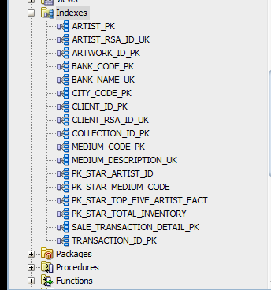
The SQL Code for each index is given in the creation of each table itself. Please refer back to creation part of document

SQL for Transactions
BEGIN
COMMIT;
SET TRANSACTION READ WRITE NAME 'TotalSalesFact';
SAVEPOINT TotalSalesFactSP;

COMMIT;
EXCEPTION
WHEN OTHERS THEN
ROLLBACK TO TotalSalesFactSP;
END;

BEGIN
COMMIT;
SET TRANSACTION READ WRITE NAME 'TopArtist';
SAVEPOINT TopArtistSP;

COMMIT;
EXCEPTION
WHEN OTHERS THEN
ROLLBACK TO TopArtistSP;
END;

BEGIN
COMMIT;
SET TRANSACTION READ WRITE NAME 'AverageSale';
SAVEPOINT AverageSaleSP;

COMMIT;
EXCEPTION
WHEN OTHERS THEN
ROLLBACK TO AverageSaleSP;
END;

BEGIN
COMMIT;
SET TRANSACTION READ WRITE NAME 'TotalInventory';
SAVEPOINT TotalInventorySP;

COMMIT;
EXCEPTION
WHEN OTHERS THEN
ROLLBACK TO TotalInventorySP;
END;

4. Regular Update/Refresh of Data from Operational Database or External Sources

SQL to populate table TOTAL_SALES
INSERT INTO total_sales_fact
SELECT DISTINCT EXTRACT(YEAR FROM st.sales_date) "Year",
EXTRACT(MONTH FROM st.sales_date) "Month",
a.artist_id,SUM(st.sales_total) "Total_Amount"
FROM
artist a, sale_transaction st, sale_transaction_detail std,
artwork art,collection c
WHERE
a.artist_id = c.artist_id
AND c.collection_id = art.collection_id
AND art.artwork_id = std.artwork_id
AND std.transaction_id = st.transaction_id
GROUP BY
EXTRACT(YEAR FROM st.sales_date),EXTRACT(MONTH FROM st.sales_date),a.artist_id,"Total_Amount";

DIMENTION TABLE
INSERT INTO artist_dim
SELECT DISTINCT tsf.artist_id, a.artist_lname, a.artist_inits, a.artist_cell
FROM total_sales_fact tsf, artist a
WHERE tsf.artist_id = a.Artist_id;

SQL to regulate update to TOTAL_SALES
FACT TABEL

INSERT INTO total_sales_fact
SELECT DISTINCT EXTRACT(YEAR FROM st.sales_date) "Year",
EXTRACT(MONTH FROM st.sales_date) "Month",
a.artist_id, SUM(st.sales_total) "Total_Amount"
FROM
artist a, sales_stransaction st, sales_transaction_detail std,
artwork art,collection c
WHERE
EXTRACT(YEAR FROM st.sales_date) = EXTRACT(YEAR FROM SYSDATE)
AND EXTRACT(MONTH FROM st.sales_date) = EXTRACT(MONTH FROM SYSDATE)
GROUP BY EXTRACT(YEAR FROM st.sales_date),
EXTRACT(MONTH FROM st.sales_date),a.artist_id;

ALTER TABLE
avg_price_medium_fact DISABLE CONSTRAINT PK_medium_code;
ALTER TABLE
avg_price_medium_fact DISABLE CONSTRAINT FK_STAR_medium_code;

INSERT INTO avg_price_medium_fact
SELECT m.medium_code, AVG(sales_price) AS Average_Sales_Price
FROM sale_transaction_detail std,
artwork art,art_ medium m
WHERE m.medium_code = art. medium_code
AND art.artwork_id = std.artwork_id
GROUP BY m.medium_code;

DIMENTION TABLE
INSERT INTO medium_dim
SELECT DISTINCT apmf.medium_code, m.medium_description
FROM avg_price_medium_fact apmf, medium m
WHERE apmf.medium_code = m.medium_code;

SQL to regulate update to AVERAGE_SALES
FACT TABEL

INSERT INTO avg_price_medium_fact
SELECT m.medium_code, AVG(sales_price) AS Average_Sales_Price
FROM
sales_transaction_st ,sales_transaction_detail std,
artwork art, medium m
WHERE
m.medium_code = art. medium_code
AND art.artwork_id = std.artwork_id
AND std.transaction_id = st. transaction_id
AND st.sales_date > SYSDATE -1
GROUP BY m.medium_code;

SQL to provide info to users
SELECT t.medium_code , Average_Sales_Price
FROM avg_price_medium_fact t, medium_dim s
WHERE t. medium_code = s. medium_code;

ALTER TABLE
average_age_client_fact DISABLE CONSTRAINT PK_STAR_average_age_client;

INSERT INTO average_age_client_fact
SELECT DISTINCT EXTRACT( YEAR FROM SYSDATE ) "Year",
EXTRACT( MONTH FROM SYSDATE ) "Month",
AVERAGE(TO_CHAR(SUBSTR(SYSDATE, 1, 2), 'YYYY')- TO_CHAR(SUBSTR(c.client_rsa_id, 1, 2), 'YYYY') ) "Average_Age"
FROM client c
GROUP BY "Year", "Month", "Average_Age";

DIMENTION TABLE

SQL to regulate update to AVERAGE_AGE_CLIENT
FACT TABEL

UPDATE average_age_client_fact accf
SET
aacf.Year = (SELECT DISTINCT EXTRACT( YEAR FROM SYSDATE)),
aacf.Month = (SELECT EXTRACT(MONTH FROM SYSDATE)),
aacf.Average_Age = (SELECT AVERAGE( TO_CHAR(SUBSTR(SYSDATE, 1, 2), 'YYYY')-
TO_CHAR(SUBSTR(c.client_rsa_id, 1, 2), 'YYYY'))
FROM client)
WHERE
EXTRACT(YEAR FROM aacf.Year) <> EXTRACT(YEAR FROM SYSDATE)
AND EXTRACT(MONTH FROM aacf.Month) <> EXTRACT( MONTH FROM SYSDATE);

SQL to populate table TOTAL_INVENTORY
ALTER TABLE
total_inventory_fact DISABLE CONSTRAINT PK_total_inventory;
ALTER TABLE
total_inventory_fact DISABLE CONSTRAINT FK_STAR_collection_id;

FACT TABEL
INSERT INTO total_inventory_fact
SELECT DISTINCT EXTRACT(YEAR FROM st.sale_date) "Year",
EXTRACT(MONTH FROM st.sale_date) "Month",
c.collection_id,COUNT(art.artwork_id) "Total_ Inventory"
FROM sale_transaction st, sale_transaction_detail std,
artwork art,collection c
WHERE
c.collection_id = art.collection_id
AND art.artwork_id = std.artwork_id
AND std.transaction_id = st.transaction_id
GROUP BY
EXTRACT(YEAR FROM st.sale_date),EXTRACT(MONTH FROM st.sale_date),c.collection_id;
DIMENTION TABLE
INSERT INTO collection_dim
SELECT DISTINCT tif. collection_id, c.Collection_name
FROM total_inventory_fact tif, collection c
WHERE tif. collection_id = c. collection_id;

SQL to regulate update to TOTAL_INVENTORY
FACT TABEL
INSERT INTO total_inventory_fact
SELECT DISTINCT EXTRACT(YEAR FROM st.sales_date) "Year",
EXTRACT(MONTH FROM st.sales_date) "Month",
c.collection_id,COUNT(art.artwork_id) "Total_ Inventory "
FROM
sales_stransaction st, sales_transaction_detail std,
artwork art,collection c
WHERE
EXTRACT(YEAR FROM st.sales_date) = EXTRACT(YEAR FROM SYSDATE)
AND EXTRACT(MONTH FROM st.sales_date) = EXTRACT(MONTH FROM SYSDATE)
GROUP BY EXTRACT(YEAR FROM st.sales_date),
EXTRACT(MONTH FROM st.sales_date), c.collection_id;

SQL to provide info to users
SELECT t.year, t.month, t.collection_id, t.total_inventory
FROM total_inventory_fact t, collection_dim s
WHERE t.collection_id = s.collection_id;

5. SQL Queries to Provide Information for Decision Making

This view will display all artist who has not passed away.
CREATE OR REPLACE VIEW Display_Living_Artist
AS SELECT artist_lname, artist_dob
FROM artist
WHERE artist_dod IS NOT NULL;

created.

CREATE OR REPLACE VIEW Calculate_Artwork_Age
AS SELECT artwork_id, artwork_title, TO_CHAR(artwork_doc,'DD, "of" MONTH, YYYY') AS "DATE OF CREATION",TO_CHAR(SYSDATE,'YYYY') - TO_CHAR(artwork_doc,'YYYY') AS "ARTWORK_AGE"
FROM ARTWORK
ORDER BY artwork_age DESC;

This view will find clients according to their last name, the user will also be prompted to enter the last name
CREATE OR REPLACE VIEW Find_Clients
AS SELECT *
FROM KLIENT WHERE client_lname LIKE '&client_lname%';

This view will only display artwork that must be shipped
CREATE OR REPLACE VIEW Shipped_Artwork
AS SELECT transaction_id,sale_date
FROM sale_transaction
WHERE delivery_method = 'Ship'
OR (delivery_method = 'Ship International');

This view display the transaction where the artwork was sold at a zero profit.
CREATE OR REPLACE VIEW ZERO_PROFIT_SALE
AS SELECT s.transaction_id, s.delivery_method, s.sales_total, d.artwork_id
FROM SALE_TRANSACTION s
INNER JOIN SALE_TRANSACTION_DETAIL d
ON (s.transaction_id = d.transaction_id)
WHERE d.sales_price = s.sales_total
AND s.commission = 0.0;

This view will prompt the user to insert a collection ID he/she desires to see. Also known as substitution variable
DEFINE collection_number =1
CREATE OR REPLACE VIEW ARTWORK_IN_COLLECTION
AS SELECT INITCAP(artwork_title) AS "ARTWORK TITLE", artwork_doc AS "DATE OF CREATION", length_cm, width_cm,art_status AS "STATUS", TO_CHAR(art_estimated_value,'L99,999.00') AS "ESTIMATED VALUE"
FROM ARTWORK
WHERE COLLECTION_ID = &collection_number
ORDER BY artwork_doc ASC;
UNDEFINE collection_number;
DEFINE artwork_value =10000
CREATE OR REPLACE VIEW ARTWORK_ESTIMATED_VALUE
AS SELECT INITCAP(artwork_title) AS "ARTWORK TITLE", artwork_doc AS "DATE OF CREATION", length_cm, width_cm,art_status AS "STATUS", TO_CHAR(art_estimated_value,'L99,999.00') AS "ESTIMATED VALUE"
FROM ARTWORK
WHERE art_estimated_value = &artwork_value
ORDER BY artwork_doc ASC;
UNDEFINE artwork_value;

This view will calculate the annual sales between certain time periods
CREATE OR REPLACE VIEW ANNUAL_SALES
AS SELECT transaction_id,sale_date, sales_total, commission, vat, client_id, delivery_method
FROM sale_transaction
WHERE EXTRACT(YEAR FROM sale_date)
BETWEEN TRUNC(EXTRACT (YEAR FROM SYSDATE)) AND ROUND(EXTRACT (YEAR FROM SYSDATE));

This view will calculate the commission goals the museum wants to display
CREATE OR REPLACE VIEW COMMISSION_GOAL
AS SELECT transaction_id,EXTRACT(MONTH FROM TO_DATE(sale_date)) AS "MONTH OF SALE", sales_total, commission, vat
FROM sale_transaction
GROUP BY EXTRACT(MONTH FROM TO_DATE(sale_date)), TO_DATE(sale_date), sale_date, sales_total, transaction_id,
commission, vat
HAVING SUM(sales_total) >= 10000;

This view will calculate the sum of the commission, VAT, sales total and net sales
CREATE OR REPLACE VIEW Net_Sales
AS SELECT transaction_id, SUM(commission) AS "Total Commission", SUM(vat) AS "Total VAT" , SUM(sales_total) AS "Total Sales",
TO_CHAR(SUM(sales_total)-SUM(commission)-SUM(vat),'L99,999.00') AS "Net sales"
FROM sale_transaction
WHERE TO_CHAR(sale_date, 'DD') = TO_CHAR(SYSDATE,'DD')
GROUP BY transaction_id;

CREATE OR REPLACE VIEW COMMISSION_GOAL
AS SELECT transaction_id,EXTRACT(MONTH FROM TO_DATE(sale_date)) AS "MONTH OF SALE", sales_total, commission, vat
FROM sale_transaction
GROUP BY EXTRACT(MONTH FROM TO_DATE(sale_date)), TO_DATE(sale_date), sale_date, sales_total, transaction_id,
commission, vat
HAVING SUM(sales_total) >= 10000;

This view extracts the data from three tables to show only the relevant information to the deliveryman/ museum about the artwork that needs to be delivered.
CREATE OR REPLACE VIEW DELIVERY_LIST
AS SELECT s.transaction_id, s.delivery_method, INITCAP(c.client_lname) AS "Last Name",
c.client_rsa_id, c.client_cell, c.client_street_address, c.street_nr, t.city_name, t.city_postal_code
FROM SALE_TRANSACTION s
INNER JOIN KLIENT c
ON (s.client_id = c.client_id)
INNER JOIN CITY t
ON (c.city_code = t.city_code);

This view displays only the sales and important information regarding the sales of the current month
CREATE OR REPLACE VIEW MONTHLY_SALES
AS SELECT s.transaction_id, a.artwork_id, t.sale_date, a.artwork_title, c.collection_name, TO_CHAR(s.sales_price,'L99,999.00') AS "Sales Price"
FROM SALE_TRANSACTION_DETAIL s
INNER JOIN SALE_TRANSACTION t
ON (s.transaction_id = t.transaction_id)
INNER JOIN ARTWORK a
ON (s.artwork_id = a.artwork_id)
INNER JOIN COLLECTION c
ON (a.collection_id = c.collection_id)
WHERE TO_CHAR(t.sale_date,'MM') = TO_CHAR(SYSDATE,'MM')
ORDER BY t.sale_date ASC;

This view will only display artwork that has been sold
CREATE OR REPLACE VIEW Display_Specific_Artwork_Sold
AS SELECT artwork_id,INITCAP(artwork_title) AS "Title"
FROM artwork a
WHERE artwork_id = (SELECT s.artwork_id
FROM sale_transaction_detail s
WHERE s.artwork_id = 2000);

6. Optimized SQL Statements
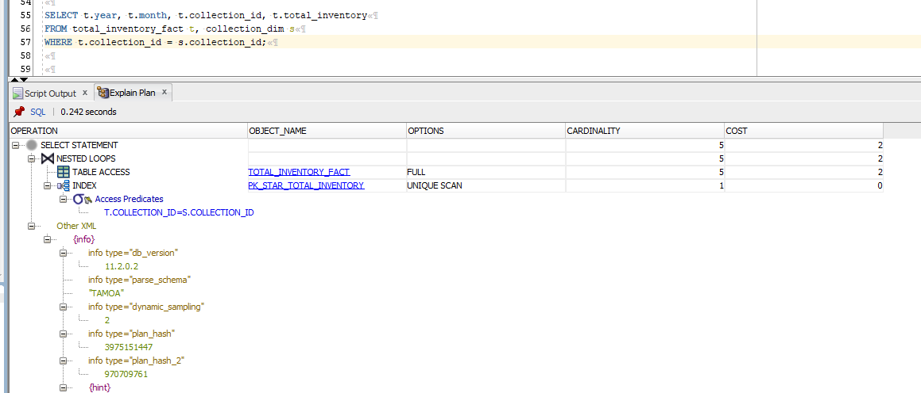

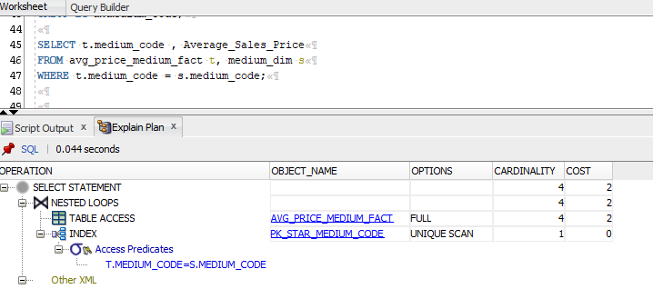

7. Database Created in Oracle

CITY Table
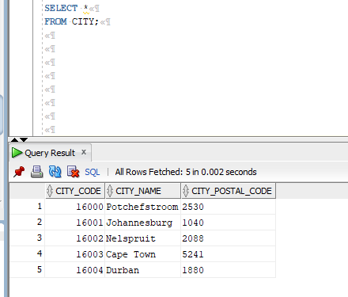
KLIENT Table
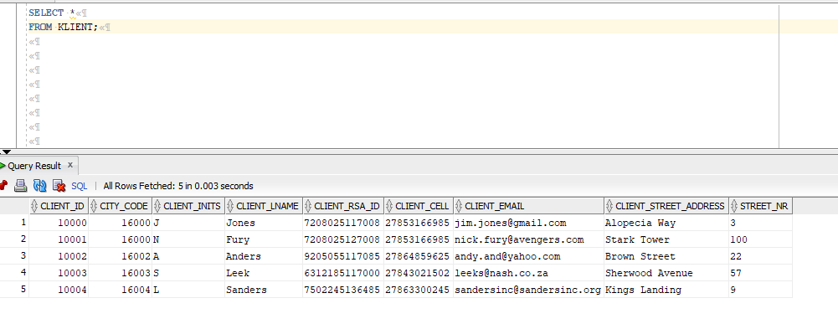

SALES_TRANSACTION Table
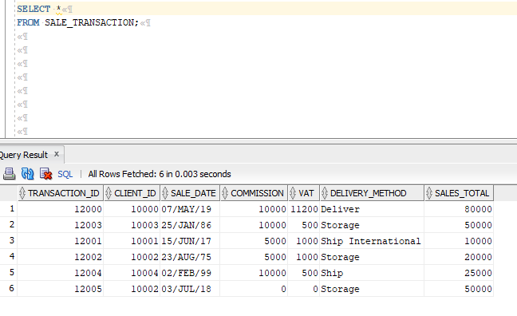

SALE_TRANSACTION_DETAIL Table
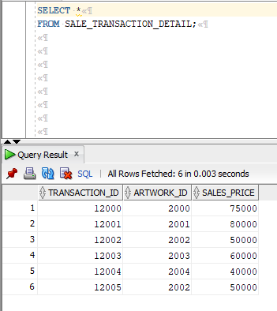

ARTWORK Table
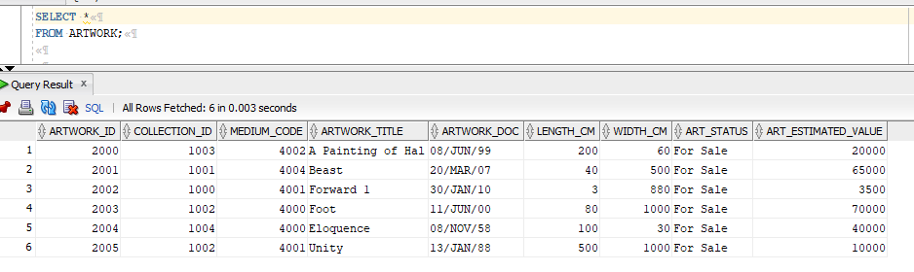
COLLECTION Table
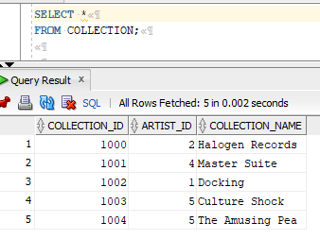
ART_MEDIUM Table
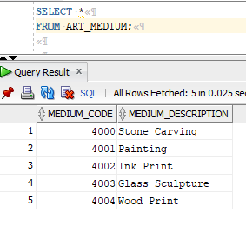

ARTIST Table
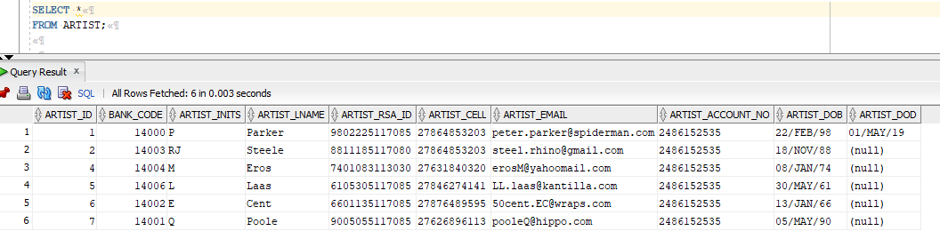

BANK Table
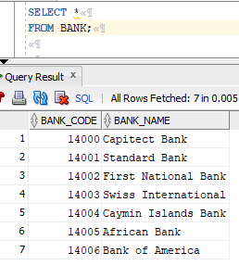

8. Extra Functionality

Charts and Reporting
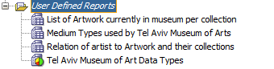

List of Artwork Currently in Museum per Collection
Type | Table
SQL Query | select c.collection_name "Collection", w.artwork_title "Title", art_status "Status"  from collection c  JOIN artwork w  on (c.collection_id = w.collection_id)

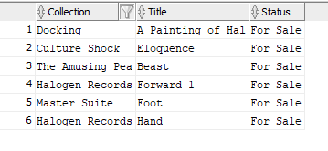
Output:

Medium Types Used by Tel Aviv Museum of Arts
Type | Table
SQL Query | Select medium_description  from art_medium

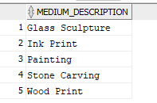
Output:

Relation of Artist to Artwork and Their Collections
Type | Table
SQL Query | select a.artist_lname "Last Name", a.artist_inits "Ïnitials", c.collection_name "Collection", w.artwork_title "Title"  from artist a  JOIN collection c  on (a.artist_id = c.artist_id)  JOIN artwork w  on (c.collection_id = w.collection_id)

Output:
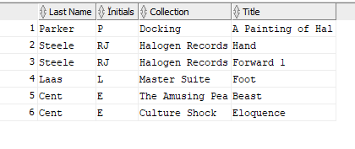

Tel Aviv Museum of Art Data Types
Type | Chart (HTML)
Chart Type | Bar - Horizontal Cluster
SQL Query | select table_name, data_type,  count(data_type)  from all_tab_columns  where owner = 'TAMOA'  group by table_name, data_type
Style | 3D Effect
Data | Use Live Data
Titles | Data Types for Tables in the Tel Aviv Museum of Art Schema
Plot area | Custom Colours
X-Axis | Title: Table Names; Alignment: Center; Line Width: Thinnest
Y-Axis | Title: Occurrences of Data Types; Alignment: Center; Scale: Set Automatically
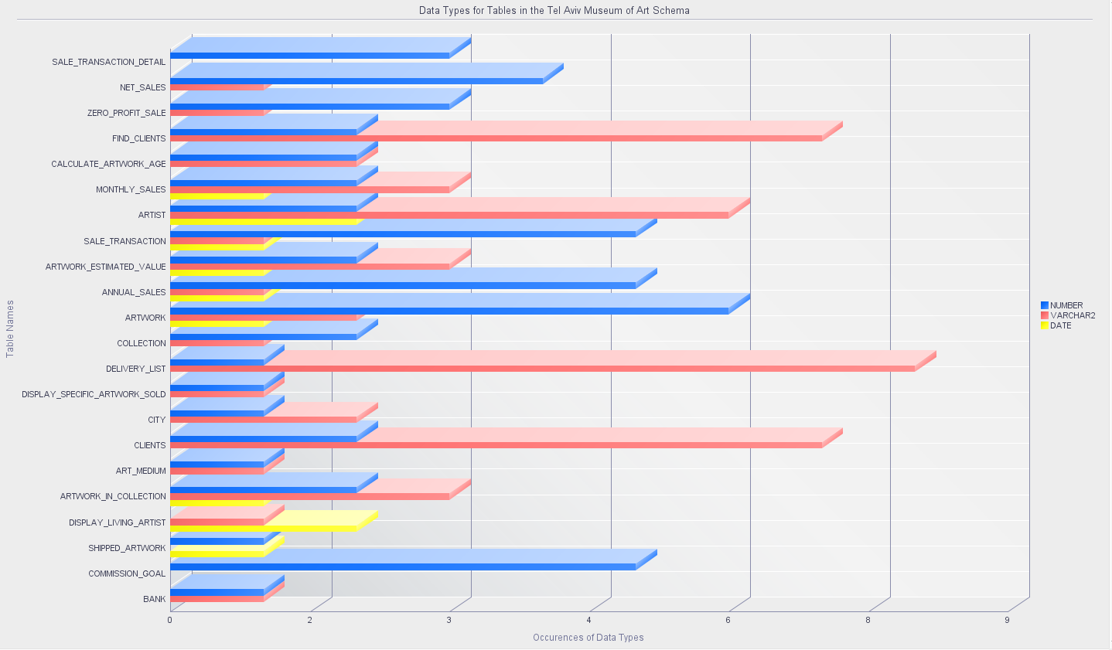
Output:

